Ox version 3.40 (Windows) (C) J.A. Doornik, 1994-2004
Descriptive Statistics package version 1.0, object created on 18-03-2006

Algebra code for Data2.xls:
"EMBI+ BZ JPM2" = "EMBI+ BZ JPM"/(1+0.01*("EMBI+ BZ JPM"+"TREAS 7Y"));
"LEMBI+ BZ JPM2" = log("EMBI+ BZ JPM2"*0.01);

Ox version 3.40 (Windows) (C) J.A. Doornik, 1994-2004
Arfima package version 1.02, object created on 18-03-2006

Algebra code for Data2.xls:
"Baa Spread" = FBAA-"TREAS 7Y";

---- Non-linear least squares estimation of ARFIMA(1,0,0) model ----
The estimation sample is: 1995 (23) - 2005 (48)
The dependent variable is: LEMBI+ BZ JPM2 (Data2.xls)

Coefficient Std.Error t-value t-prob
AR-1 0.986951 0.007320 135. 0.000
Constant -3.37535 0.2106 -16.0 0.000
Baa Spread 0.202076 0.03529 5.73 0.000

log-likelihood 817.900452
no. of observations 546 no. of parameters 4
AIC.T -1627.8009 AIC -2.98132034
mean(LEMBI+ BZ JPM2) -2.7462 var(LEMBI+ BZ JPM2) 0.14818
sigma 0.0541992 sigma^2 0.00293755

BFGS using numerical derivatives (eps1=0.0001; eps2=0.005):
Strong convergence
Used starting values:
0.97762 -3.5293 0.33447

BFGS using numerical derivatives (eps1=0.0001; eps2=0.005):
Strong convergence
Used starting values:
0.97762 -3.5293 0.33447

Portmanteau statistic for residuals
Autocorrelation function (ACF) from lag 1 to 52:
0.16112 0.11635 -0.027779 -0.022242 -0.056016 -0.0051455
-0.0023763 0.012034 -0.052501 0.033455 0.019471 -0.014177
-0.039054 0.0098203 0.0046426 -0.026876 0.0075335 -0.012675
0.070216 -0.0072558 -0.048367 -0.063864 -0.014204 -0.010695
-0.012445 0.047841 -0.027535 0.016436 -0.042960 -0.036895
-0.0065940 0.048337 -0.018215 0.056079 0.00091494 0.032969
-0.033591 0.0064638 0.062413 -0.0068473 -0.010802 0.056065
0.076912 -0.048480 0.0061039 -0.020282 -0.049955 -0.037006
-0.0053070 0.069376 -0.00033923 0.051453
Partial autocorrelation function (PACF):
0.16112 0.092801 -0.061864 -0.020691 -0.041196 0.012828
0.0056380 0.0063035 -0.059826 0.047868 0.022241 -0.034472
-0.036429 0.025096 0.012014 -0.036515 0.013808 -0.016595
0.080711 -0.025324 -0.072492 -0.043009 0.025197 0.0056195
-0.031715 0.050963 -0.045800 0.029595 -0.050075 -0.042017
0.022611 0.069150 -0.047223 0.033988 0.0088396 0.018386
-0.032131 -0.0065162 0.083169 -0.023298 -0.0049062 0.046746
0.067030 -0.075858 0.0027152 -0.0096977 -0.042366 0.0081640
-0.0070430 0.072107 -0.036587 0.059170
Portmanteau(52): Chi^2(51)= 59.516 [0.1934]

ARCH coefficients:
Lag Coefficient Std.Error
1 0.03072 0.04297
RSS = 0.0882187 sigma = 0.0127697

Testing for error ARCH from lags 1 to 1
ARCH 1-1 test: F(1,541) = 0.51107 [0.4750]

Results saved to D:\TESES MESTRADO\emetricsmarch2004\MODELO 1 Default X Risk Aversion\Extensão de prazo e INPUT NOVO\semanal\protocolo semanal.out

---- Non-linear least squares estimation of ARFIMA(1,0,0) model ----
The estimation sample is: 1999 (5) - 2005 (48)
The dependent variable is: LEMBI+ BZ JPM2 (Data2.xls)

Coefficient Std.Error t-value t-prob
AR-1 0.991621 0.007486 132. 0.000
Constant -3.52470 0.4583 -7.69 0.000
Baa Spread 0.159010 0.03287 4.84 0.000

log-likelihood 596.669517
no. of observations 356 no. of parameters 4
AIC.T -1185.33903 AIC -3.32960403
mean(LEMBI+ BZ JPM2) -2.7022 var(LEMBI+ BZ JPM2) 0.147667
sigma 0.0454038 sigma^2 0.0020615

BFGS using numerical derivatives (eps1=0.0001; eps2=0.005):
Strong convergence
Used starting values:
0.97573 -3.7439 0.39287

---- Non-linear least squares estimation of ARFIMA(1,0,0) model ----
The estimation sample is: 1999 (5) - 2004 (4)
The dependent variable is: LEMBI+ BZ JPM2 (Data2.xls)

Coefficient Std.Error t-value t-prob
AR-1 0.987641 0.01165 84.8 0.000
Constant -3.53244 0.4008 -8.81 0.000
Baa Spread 0.236503 0.03984 5.94 0.000

log-likelihood 428.948373
no. of observations 260 no. of parameters 4
AIC.T -849.896745 AIC -3.26883364
mean(LEMBI+ BZ JPM2) -2.53828 var(LEMBI+ BZ JPM2) 0.088917
sigma 0.0466595 sigma^2 0.00217711

BFGS using numerical derivatives (eps1=0.0001; eps2=0.005):
Strong convergence
Used starting values:
0.96504 -3.2336 0.24678

---- Non-linear least squares estimation of ARFIMA(1,0,0) model ----
The estimation sample is: 1995 (23) - 2004 (4)
The dependent variable is: LEMBI+ BZ JPM2 (Data2.xls)

Coefficient Std.Error t-value t-prob
AR-1 0.981885 0.009510 103. 0.000
Constant -3.43194 0.1894 -18.1 0.000
Baa Spread 0.271176 0.04131 6.56 0.000

log-likelihood 657.590977
no. of observations 450 no. of parameters 4
AIC.T -1307.18195 AIC -2.90484878
mean(LEMBI+ BZ JPM2) -2.66087 var(LEMBI+ BZ JPM2) 0.130512
sigma 0.0562458 sigma^2 0.00316359

BFGS using numerical derivatives (eps1=0.0001; eps2=0.005):
Strong convergence
Used starting values:
0.97092 -3.3894 0.30726

Data2.xls saved to D:\TESES MESTRADO\emetricsmarch2004\MODELO 1 Default X Risk Aversion\Extensão de prazo e INPUT NOVO\semanal\Data3.xls

TESTE AMOSTRA BAA MENOR QUE 2,5%

---- Non-linear least squares estimation of ARFIMA(1,0,0) model ----
The estimation sample is: 1995 (23) - 2003 (21)
The dependent variable is: LEMBI+ BZ JPM2 (Data3)

Coefficient Std.Error t-value t-prob
AR-1 0.981266 0.008896 110. 0.000
Constant -4.03539 0.1873 -21.5 0.000
Baa Spread 0.498835 0.02293 21.8 0.000

log-likelihood 556.157432
no. of observations 415 no. of parameters 4
AIC.T -1104.31486 AIC -2.66099967
mean(LEMBI+ BZ JPM2) -2.84186 var(LEMBI+ BZ JPM2) 0.129817
sigma 0.0635034 sigma^2 0.00403268

BFGS using numerical derivatives (eps1=0.0001; eps2=0.005):
Strong convergence
Used starting values:
0.97123 -3.4075 0.26651

---- Non-linear least squares estimation of ARFIMA(1,0,0) model ----
The estimation sample is: 1995 (23) - 2001 (29)
The dependent variable is: LEMBI+ BZ JPM2 (Data3)

Coefficient Std.Error t-value t-prob
AR-1 0.982915 0.01016 96.7 0.000
Constant -3.17985 0.2324 -13.7 0.000
Baa Spread 0.0862561 0.04713 1.83 0.068

log-likelihood 463.434997
no. of observations 319 no. of parameters 4
AIC.T -918.869993 AIC -2.8804702
mean(LEMBI+ BZ JPM2) -2.84013 var(LEMBI+ BZ JPM2) 0.0995715
sigma 0.0567802 sigma^2 0.00322399

BFGS using numerical derivatives (eps1=0.0001; eps2=0.005):
Strong convergence
Used starting values:
0.97626 -3.0438 0.10449

---- Non-linear least squares estimation of ARFIMA(1,0,0) model ----
The estimation sample is: 1999 (5) - 2001 (29)
The dependent variable is: LEMBI+ BZ JPM2 (Data3)

Coefficient Std.Error t-value t-prob
AR-1 1.00000 7.861e-0061.272e+005 0.000
Constant 2557.84 418.1 6.12 0.000
Baa Spread 0.0117865 0.04044 0.291 0.771

log-likelihood 227.525742
no. of observations 129 no. of parameters 4
AIC.T -447.051483 AIC -3.46551538
mean(LEMBI+ BZ JPM2) -2.83914 var(LEMBI+ BZ JPM2) 0.0595032
sigma 0.0417986 sigma^2 0.00174713

BFGS using numerical derivatives (eps1=0.0001; eps2=0.005):
Strong convergence
Used starting values:
0.94101 -2.0565 -0.34206

---- Non-linear least squares estimation of ARFIMA(1,0,0) model ----
The estimation sample is: 1999 (5) - 2003 (21)
The dependent variable is: LEMBI+ BZ JPM2 (Data3)

Coefficient Std.Error t-value t-prob
AR-1 0.972786 0.01320 73.7 0.000
Constant -4.24665 0.1792 -23.7 0.000
Baa Spread 0.512016 0.02304 22.2 0.000

log-likelihood 306.970025
no. of observations 225 no. of parameters 4
AIC.T -605.940051 AIC -2.69306689
mean(LEMBI+ BZ JPM2) -2.84274 var(LEMBI+ BZ JPM2) 0.132384
sigma 0.0621139 sigma^2 0.00385814

BFGS using numerical derivatives (eps1=0.0001; eps2=0.005):
Strong convergence
Used starting values:
0.96345 -3.6759 0.33827

Results saved to D:\TESES MESTRADO\emetricsmarch2004\MODELO 1 Default X Risk Aversion\Extensão de prazo e INPUT NOVO\semanal\protocolo semanal.out

Data2.xls loaded from D:\TESES MESTRADO\emetricsmarch2004\MODELO 1 Default X Risk Aversion\Extensão de prazo e INPUT NOVO\semanal\Data2.xls

Results saved to D:\TESES MESTRADO\emetricsmarch2004\MODELO 1 Default X Risk Aversion\Extensão de prazo e INPUT NOVO\semanal\protocolo semanal.out

Tudo foi feito supondo AR1, só que parece ser AR4,

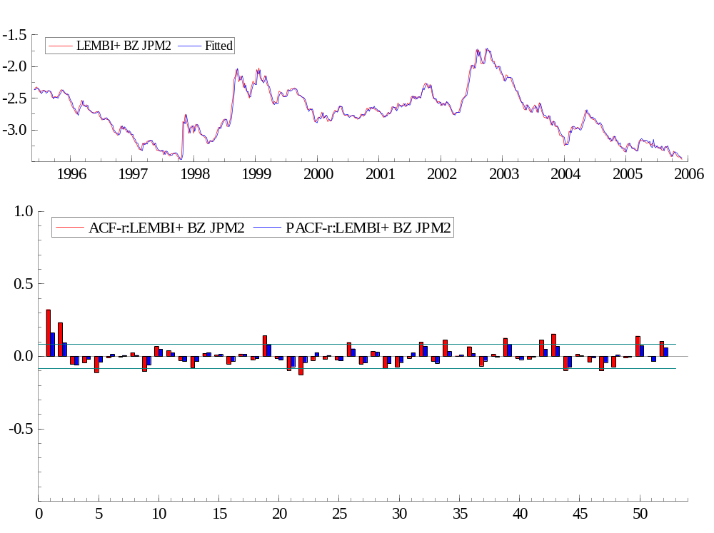
---- Non-linear least squares estimation of ARFIMA(2,0,0) model ----
The estimation sample is: 1995 (23) - 2005 (48)
The dependent variable is: LEMBI+ BZ JPM2 (Data2.xls)

Coefficient Std.Error t-value t-prob
AR-1 1.14874 0.04233 27.1 0.000
AR-2 -0.164406 0.04232 -3.88 0.000
Constant -3.31347 0.1732 -19.1 0.000
Baa Spread 0.194558 0.03584 5.43 0.000

log-likelihood 825.461395
no. of observations 546 no. of parameters 5
AIC.T -1640.92279 AIC -3.00535309
mean(LEMBI+ BZ JPM2) -2.7462 var(LEMBI+ BZ JPM2) 0.14818
sigma 0.0534538 sigma^2 0.00285731

BFGS using numerical derivatives (eps1=0.0001; eps2=0.005):
Strong convergence
Used starting values:
1.0937 -0.11875 -3.5293 0.33447

Portmanteau statistic for residuals
Autocorrelation function (ACF) from lag 1 to 52:
-0.016791 0.10545 -0.039706 -0.0039401 -0.049583 0.0099064
0.00092972 0.026334 -0.059607 0.045092 0.021590 -0.0076204
-0.035958 0.020786 0.010444 -0.026476 0.018406 -0.022435
0.079369 -0.0087880 -0.036253 -0.053876 0.00047880 -0.0050897
-0.017681 0.058238 -0.037680 0.031686 -0.038812 -0.027467
-0.0064615 0.057411 -0.033707 0.064921 -0.012110 0.040582
-0.041329 0.0025774 0.066191 -0.012685 -0.017770 0.048410
0.081073 -0.062549 0.020375 -0.011872 -0.040595 -0.027644
-0.010221 0.075045 -0.020342 0.054040
Partial autocorrelation function (PACF):
-0.016791 0.10520 -0.036772 -0.016242 -0.042330 0.0096097
0.010184 0.021393 -0.061474 0.037916 0.038405 -0.019025
-0.040200 0.020513 0.023727 -0.031446 0.014825 -0.023914
0.082657 0.0023481 -0.063088 -0.055097 0.018418 0.015548
-0.035824 0.054255 -0.038869 0.033911 -0.034632 -0.048552
0.0059275 0.080808 -0.036273 0.029501 0.012637 0.025834
-0.026355 -0.023412 0.083884 -0.0053449 -0.012510 0.032546
0.086180 -0.060254 -0.0050956 -0.0030354 -0.042373 0.0034088
-0.018190 0.075656 -0.033415 0.058927
Portmanteau(52): Chi^2(50)= 49.846 [0.4795]

Normality test for residuals
Observations 546
Mean 1.8690e-007
Std.Devn. 0.053356
Skewness 2.1008
Excess Kurtosis 16.495
Minimum -0.14820
Maximum 0.51265
Asymptotic test: Chi^2(2) = 6591.4 [0.0000]**
Normality test: Chi^2(2) = 236.92 [0.0000]**

ARCH coefficients:
Lag Coefficient Std.Error
1 0.072519 0.04292
RSS = 0.0814022 sigma = 0.0122778

Testing for error ARCH from lags 1 to 1
ARCH 1-1 test: F(1,540) = 2.8550 [0.0917]
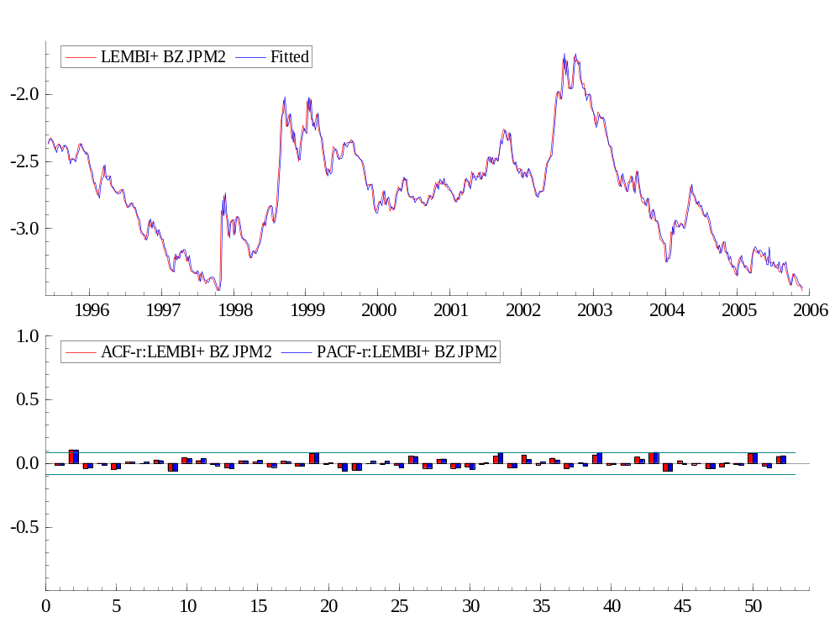

---- Non-linear least squares estimation of ARFIMA(2,0,0) model ----
The estimation sample is: 1999 (5) - 2005 (48)
The dependent variable is: LEMBI+ BZ JPM2 (Data2.xls)

Coefficient Std.Error t-value t-prob
AR-1 1.21424 0.05223 23.2 0.000
AR-2 -0.224898 0.05216 -4.31 0.000
Constant -3.33177 0.2862 -11.6 0.000
Baa Spread 0.142125 0.03340 4.26 0.000

log-likelihood 605.887348
no. of observations 356 no. of parameters 5
AIC.T -1201.7747 AIC -3.37577162
mean(LEMBI+ BZ JPM2) -2.7022 var(LEMBI+ BZ JPM2) 0.147667
sigma 0.0442433 sigma^2 0.00195747

BFGS using numerical derivatives (eps1=0.0001; eps2=0.005):
Strong convergence
Used starting values:
1.1020 -0.12942 -3.7439 0.39287
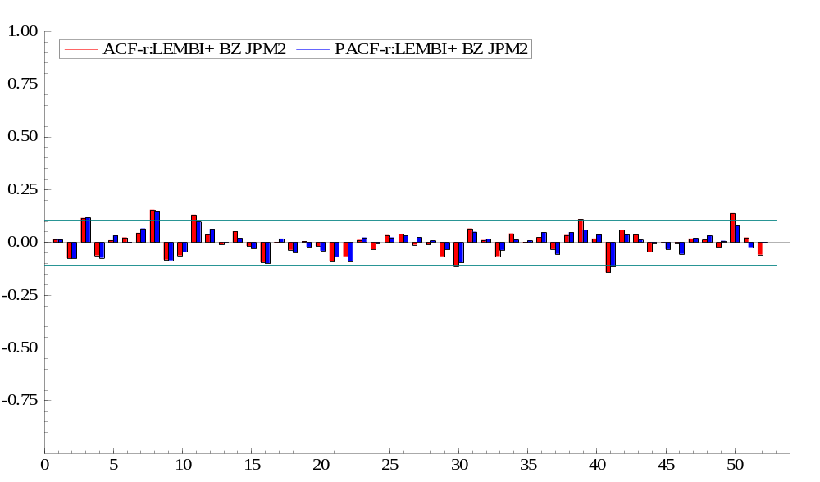

---- Non-linear least squares estimation of ARFIMA(2,0,0) model ----
The estimation sample is: 1999 (5) - 2004 (4)
The dependent variable is: LEMBI+ BZ JPM2 (Data2.xls)

Coefficient Std.Error t-value t-prob
AR-1 1.20805 0.06079 19.9 0.000
AR-2 -0.227107 0.06125 -3.71 0.000
Constant -3.35050 0.2127 -15.8 0.000
Baa Spread 0.229121 0.04084 5.61 0.000

log-likelihood 435.906237
no. of observations 260 no. of parameters 5
AIC.T -861.812473 AIC -3.31466336
mean(LEMBI+ BZ JPM2) -2.53828 var(LEMBI+ BZ JPM2) 0.088917
sigma 0.0454274 sigma^2 0.00206365

BFGS using numerical derivatives (eps1=0.0001; eps2=0.005):
Strong convergence
Used starting values:
1.1332 -0.17422 -3.2336 0.24678

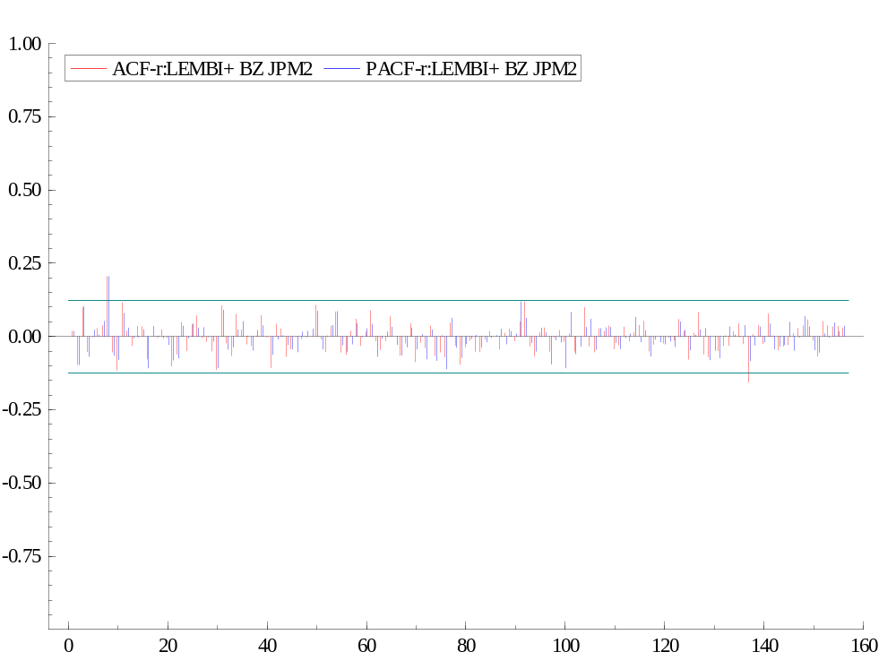

---- Non-linear least squares estimation of ARFIMA(2,0,0) model ----
The estimation sample is: 1995 (23) - 2004 (4)
The dependent variable is: LEMBI+ BZ JPM2 (Data2.xls)

Coefficient Std.Error t-value t-prob
AR-1 1.14296 0.04655 24.6 0.000
AR-2 -0.165377 0.04673 -3.54 0.000
Constant -3.39006 0.1583 -21.4 0.000
Baa Spread 0.270814 0.04199 6.45 0.000

log-likelihood 663.851608
no. of observations 450 no. of parameters 5
AIC.T -1317.70322 AIC -2.92822937
mean(LEMBI+ BZ JPM2) -2.66087 var(LEMBI+ BZ JPM2) 0.130512
sigma 0.0554687 sigma^2 0.00307677

BFGS using numerical derivatives (eps1=0.0001; eps2=0.005):
Strong convergence
Used starting values:
1.1163 -0.14969 -3.3894 0.30726

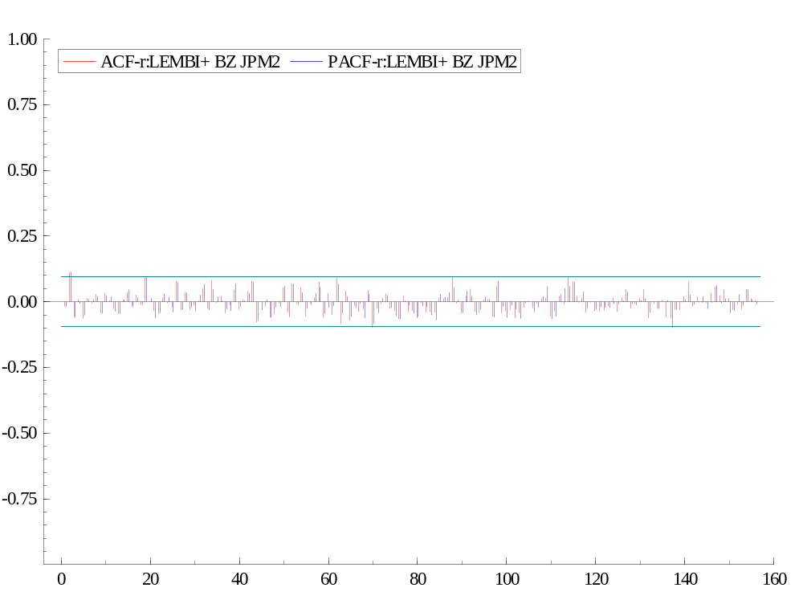

---- Non-linear least squares estimation of ARFIMA(2,0,0) model ----
The estimation sample is: 1995 (23) - 2001 (29)
The dependent variable is: LEMBI+ BZ JPM2 (Data3)

Coefficient Std.Error t-value t-prob
AR-1 1.19775 0.05475 21.9 0.000
AR-2 -0.219251 0.05480 -4.00 0.000
Constant -3.12815 0.1776 -17.6 0.000
Baa Spread 0.0915505 0.04568 2.00 0.046

log-likelihood 471.477892
no. of observations 319 no. of parameters 5
AIC.T -932.955785 AIC -2.92462628
mean(LEMBI+ BZ JPM2) -2.84013 var(LEMBI+ BZ JPM2) 0.0995715
sigma 0.0553665 sigma^2 0.00306545

BFGS using numerical derivatives (eps1=0.0001; eps2=0.005):
Strong convergence
Used starting values:
1.1633 -0.19157 -3.0438 0.10449

---- Non-linear least squares estimation of ARFIMA(2,0,0) model ----
The estimation sample is: 1999 (5) - 2003 (21)
The dependent variable is: LEMBI+ BZ JPM2 (Data3)

Coefficient Std.Error t-value t-prob
AR-1 1.12779 0.06589 17.1 0.000
AR-2 -0.157428 0.06537 -2.41 0.017
Constant -4.22231 0.1592 -26.5 0.000
Baa Spread 0.514131 0.02246 22.9 0.000

log-likelihood 309.870781
no. of observations 225 no. of parameters 5
AIC.T -609.741563 AIC -2.7099625
mean(LEMBI+ BZ JPM2) -2.84274 var(LEMBI+ BZ JPM2) 0.132384
sigma 0.0613183 sigma^2 0.00375993

BFGS using numerical derivatives (eps1=0.0001; eps2=0.005):
Strong convergence
Used starting values:
1.0542 -0.094149 -3.6759 0.33827

